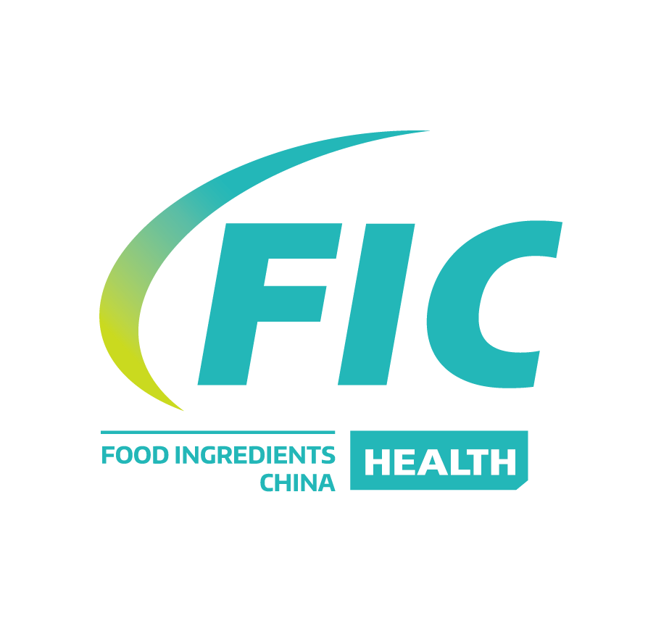

China Natural Extracts & Health Ingredients Exhibition (FIC-Health 2024) & the 23th National Food Additives and Ingredients Exhibition
- FIC-Health2024 Information
Time: November 21-23, 2024
Address:Hall 9.1, Hall 10.1, Hall 11.1, China Import and Export Fair Complex Area B (Canton Fair Complex Area B)
No.382 Yuejiangzhong Road, Guangzhou

- Exhibits
- Food Additives: Acidity regulator, Anti-caking agent, deforming agent, Antioxidant, Bleaching agent, Bulking agent, Chewing gum base, Coating agent, Color, Color fixative, Compound food additives, Emulsifier, Enzyme, Edible flavor and fragrance, Flavor enhancer, Flour treatment agent, Humectant, Nutrition enhancer, Preservative, Stabilizer and coagulator, Sweetener, Thickener, , Fragrances, Flavors, food additive compound and 23 main categories.
- Food Ingredients: Starch, Modified starch, Starch sugar, Sugar alcohols, Oligos, Grease for food industry, Flour for special purpose, Yeast product, Vegetable protein, Dehydrated/frozen dried fruit and meat, Frozen/chilled food, Fillings, Condiment, Spice, Diary product, Animal and plant extract, Beverage concentrate, Curing agent, Soy product, Protein polypeptide, Dried fruits and nuts, Instant tea, Functional food additives, Cocoa product, Edible fiber, Egg product, Honey product, Bean, Roasted seed and nut，Probiotics, snack food, and 35 other main categories.
- Food Processing Aids: Releasing agent, Anti-sticking agent, Anti-foaming agent, Dispersant, Clarifying agent, Flocculating agent, Chelating agent, Filter aid, Decoloring agent, Adsorbent, Nutrient substance for fermentation, Catalytic agent, Crystallizing agent, Solvent.
- Food Processing Aids Equipment, Machinery and Technologies, Food packing material and related books.
E.Health Food, geriatric food, Moslem food, Kosher food
F. Producing and application technologies in Food Ingredients and Additives, health food.
G.Bakery products: Mooncake and mooncake production, pastry and pastry production, confectionery and confectionery production, cake decorations, ice cream
Cream and ice cream production, snacks and snacks production, coffee and coffee machine, baking process and research and development technology.
H.Baking raw materials and baking equipment: baking raw materials, baking additives, preservative, baking fillings, cake decorations, Baking production equipment, baking tool mold, oven and other baking related equipment, baking related laboratory and testing equipment, exhibition Cabinets, storage and refrigerated cabinets, hotel and catering equipment.
I. Food raw and auxiliary materials for hotel use.
- Booth Facilities and Fees
- Shell Package booth
Booth Size | Domestic  Exhibitors | Overseas Exhibitors | Booth Facilities
9㎡(3*3) | RMB 8000 | USD 1500 | Three sides boards,blanket, two spotlights,electric outlet, one round table, two chairs, and exhibitor' s fascia board
12㎡(3*4) | RMB 10600 | USD 2000 | Three sides boards,blanket, two spotlights,electric outlet, one round table, two chairs, and exhibitor' s fascia board
15㎡(3*5) | RMB 13300 | USD 2500 | Three sides boards,blanket, three spotlights,electric outlet, one round table, three chairs, and exhibitor' s fascia board
18㎡(3*6) | RMB 16000 | USD 3000 | Three sides boards,blanket, three spotlights,electric outlet, two round table, four chairs, and exhibitor' s fascia board

- Space-only booth (more than 18㎡): USD150/㎡.
- Corner fees:600 RMB/Corner.

China Food Additives & Ingredients Association
Add: Rm. 1402, Tower 3, Vantone, No. 6A, Chaowai St., Beijing 100020, China
Tel: +86-10-5979 5833, Fax: +86-10-5907 1335, 5907 1336
Email: cfaa1990@126.com
Contact person: Chen Yanyan, Yin Shengli, Wang Yansong, Zhang Yuechen

